Customer Sentiment Analysis Using Artificial Intelligence to Improve Fawry Plus Customer Experience
Case studies in Ai for business
Nourhan Magdy Abdallah – 23226110
Prof. Ahmed ElSeddawy
Vice Dean of Educational Affairs- Smart Village
Ahmed.Bahgat@aast.edu

Abstract
In today’s highly competitive Fintech environment, customer experience has become a key factor that directly influences business performance and long-term success. Organizations such as Fawry Plus interact with customers through both physical branches and digital platforms, which increases the importance of capturing and analyzing customer feedback effectively. Currently, customer feedback is collected through QR code surveys during branch visits and stored in Excel sheets, where it is reviewed manually. Although this approach enables data collection, it does not fully utilize the valuable insights embedded in customer comments.
This report examines how Artificial Intelligence (AI), particularly Natural Language Processing (NLP), Machine Learning (ML), and Robotic Process Automation (RPA), can be applied to enhance customer sentiment analysis. The study proposes transforming the current manual process into an automated and integrated system supported by ERP platforms. The findings suggest that adopting AI-driven analytics improves decision-making, increases operational efficiency, and enhances overall customer experience.

1. Introduction
With the rapid development of digital financial services, customer expectations have significantly increased. Customers now expect fast, reliable, and seamless service experiences across all touchpoints. In this context, companies such as Fawry Plus must continuously evaluate and improve their service quality to remain competitive in the market. Fawry Plus operates through a hybrid model that combines physical branches with digital platforms, which increases the complexity of managing customer interactions. Currently, customer feedback is collected through QR code surveys completed at branches. This feedback is then stored in Excel sheets and reviewed manually by employees. While this method allows the organization to gather customer opinions, it becomes increasingly inefficient as the number of responses grows. Customer comments often include important insights related to service quality, waiting time, employee behavior, and transaction efficiency. However, due to the limitations of manual analysis, these insights are not fully utilized. Therefore, there is a strong need for an intelligent system that can automatically analyze customer feedback and provide actionable insights in real time.

2. Business Problem
The main business problem in this case lies in the ineffective utilization of customer feedback collected through QR-based surveys at Fawry Plus branches. Although the organization successfully captures a large volume of customer responses, the current process relies heavily on manual analysis using Excel sheets, which significantly limits the ability to extract meaningful insights so it is important to be considered from operational, strategic and financial perspective.
From an operational perspective, the manual review process is time-consuming and inefficient, especially as the number of survey responses increases. Employees must read and interpret each comment individually, which delays issue identification and slows down response time. As a result, critical customer complaints such as long waiting times or service inefficiencies may not be addressed promptly. From a strategic perspective, the absence of advanced analytical tools prevents the organization from identifying patterns, trends, and recurring issues across branches. Different employees may interpret feedback differently, leading to inconsistent analysis and a lack of standardized decision-making. This limits the organization’s ability to build a data-driven strategy for improving customer experience. From a financial perspective, unresolved customer dissatisfaction can negatively impact customer retention and overall business performance. In a highly competitive FinTech environment, failure to respond quickly to customer concerns may result in loss of customers to competitors offering more responsive and personalized services.
Additionally, the current system lacks real-time analytics, predictive capabilities, and automated reporting. It does not support advanced insights such as sentiment trends, complaint categorization, or performance benchmarking across branches. This creates a gap between data collection and actionable decision-making. Therefore, the core problem is not the lack of data, but the inability to transform this data into timely, accurate, and actionable insights. This highlights the need for an AI-driven solution that automates sentiment analysis, enhances decision-making, and supports continuous improvement in customer experience.

3. Industry & Business Context
The financial technology (FinTech) industry has experienced rapid growth over the past decade, driven by increasing digitalization, mobile adoption, and customer demand for faster and more convenient financial services. In Egypt, companies such as Fawry Plus operate within a highly competitive environment where service quality, speed, and customer satisfaction play a critical role in maintaining market position. Fawry Plus provides a wide range of financial services through both physical branches and digital channels, including bill payments, money transfers, and financial transactions. This hybrid service model increases customer interaction points, making it essential for the organization to continuously monitor and improve customer experience. Before the adoption of Artificial Intelligence, customer feedback in Fawry Plus was collected through QR code surveys and stored in Excel sheets. While this approach enabled data collection, it lacked the ability to generate actionable insights in a timely and consistent manner. From a competitive perspective, FinTech companies are increasingly leveraging data analytics and AI technologies to enhance customer engagement and optimize operations. Competitors that utilize real-time analytics and automated decision-making gain a significant advantage in understanding customer needs and responding quickly to service issues.
Therefore, organizations that rely on manual processes risk falling behind in terms of efficiency, responsiveness, and customer satisfaction. This creates a strong need for digital transformation through AI-driven solutions that enable faster, more accurate, and data-driven decision-making.

4. Literature Review
Previous studies have shown that customer sentiment analysis is widely used across multiple industries such as e-commerce, banking, and telecommunications. In these sectors, organizations rely heavily on customer feedback to evaluate service performance and identify areas for improvement. Researchers emphasize that applying Artificial Intelligence techniques to analyze customer reviews enables companies to better understand customer needs and expectations, which ultimately leads to improved service quality and higher levels of customer satisfaction. At the same time, several studies highlight the limitations of traditional methods used in analyzing customer feedback. Approaches such as manual surveys, basic reporting, and Excel-based analysis are often time-consuming and inefficient, especially when dealing with large volumes of data. These methods typically focus on surface-level insights and may overlook deeper patterns, relationships, and trends within the data. As a result, decision-making tends to be reactive rather than proactive, as issues are identified only after they become significant. In contrast, AI-based approaches that utilize Natural Language Processing and Machine Learning provide more advanced and scalable solutions. These technologies are capable of processing large amounts of unstructured textual data quickly and with high accuracy. They enable organizations to automatically classify sentiment, detect recurring issues, and uncover hidden insights that may not be visible through manual analysis. This allows businesses to shift from reactive problem-solving to proactive decision-making, where potential issues can be identified and addressed early. Additionally, research indicates that integrating sentiment analysis systems with existing business platforms such as Customer Relationship Management (CRM) or Enterprise Resource Planning (ERP) systems enhances overall operational efficiency. This integration allows organizations to combine customer feedback with operational and transactional data, providing a more comprehensive view of the customer experience. As a result, management can make more informed decisions, improve service delivery, and align business strategies with customer expectations.
5. Proposed Solution
To improve the current approach, this study proposes transforming the existing manual process into a more intelligent, AI-supported system that can handle customer feedback efficiently and generate meaningful insights in real time.
In the current situation, the customer journey begins when a visitor arrives at the branch and scans a QR code after receiving the service. The customer fills out a short survey and shares their experience. This feedback is then stored in an Excel sheet, where employees later review the responses manually. While this process allows the organization to collect customer opinions, it depends heavily on human effort and takes time to analyze, especially when the number of responses increases.
In the proposed solution, the same journey starts with the customer scanning the QR code and submitting their feedback. However, instead of waiting for manual review, the data is immediately collected and processed automatically. Once the response is submitted, Natural Language Processing (NLP) begins analyzing the customer’s comment, understanding the meaning behind the words, and identifying key issues or emotions. At the same time, Machine Learning (ML) models classify the sentiment of the feedback into positive, negative, or neutral categories. As the system processes more and more responses, the results are displayed in a dynamic dashboard that provides a clear and real-time view of customer satisfaction across branches. Managers can easily identify patterns, detect recurring complaints, and monitor performance trends. If negative feedback appears, the system can highlight it immediately, allowing teams to take quick action and resolve issues before they escalate. Through this transformation, the organization moves from a slow, manual process to a smart, automated system where insights are generated instantly, decisions are supported by data, and customer experience is continuously improved.

6. AI Solution Overview

The proposed AI solution for customer sentiment analysis at Fawry Plus relies on a combination of Natural Language Processing (NLP), Machine Learning (ML), and Robotic Process Automation (RPA). Each technology performs a different role in the overall solution. NLP is responsible for understanding customer comments, ML is used to classify sentiment and detect patterns, while RPA automates repetitive workflow steps such as collecting responses and generating reports. This integrated approach improves the speed, consistency, and accuracy of feedback analysis compared with the current manual Excel-based process.

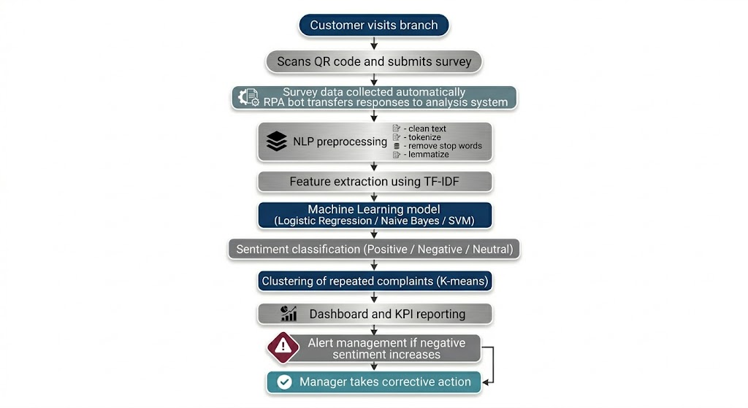

Figure 1: Proposed AI Algorithm Workflow for Customer Sentiment Analysis at Fawry Plus
6.1 Robotic Process Automation Logic
Robotic Process Automation (RPA) does not directly perform sentiment analysis; however, it plays a critical supporting role in ensuring that the entire process runs efficiently and without delays. In this context, RPA acts as the operational backbone that connects different stages of the feedback analysis workflow. Instead of relying on manual handling, RPA bots are configured to automatically collect customer responses from the QR-based survey platform as soon as they are submitted. These responses are then transferred seamlessly into the designated analysis environment, such as a database or analytics tool, without any human intervention.
In addition, RPA can be scheduled to trigger sentiment analysis processes at specific time intervals, ensuring that data is analyzed continuously rather than in batches that may cause delays. This allows the organization to maintain near real-time visibility into customer feedback. The bots can also generate dashboards and summary reports automatically, presenting insights in a structured and easy-to-understand format for management. Additionally, RPA can be programmed to send instant alerts or notifications whenever negative feedback crosses a predefined threshold, enabling quick action to address customer concerns.
Overall, the use of RPA significantly reduces the need for repetitive manual tasks, minimizes the risk of human error, and accelerates the flow of information from data collection to decision-making. In this way, RPA serves as an essential supporting layer that enhances the effectiveness of sentiment analysis systems without being directly involved in the analytical process itself.

6.2 Natural Language Processing Algorithms
Natural Language Processing is used because customer feedback is mainly written as free-text comments. These comments are unstructured, so they must be cleaned and transformed before analysis. The NLP stage begins with text preprocessing, which includes removing punctuation, converting text to lowercase, removing stop words, and tokenizing sentences into smaller units such as words or phrases. After that, techniques such as stemming or lemmatization are applied to reduce words to their root meaning.
To extract meaning from customer comments, the system can use TF-IDF (Term Frequency -Inverse Document Frequency) to identify important words in the comments. For example, repeated terms such as delay - waiting - slow or helpful help the system understand the main issues affecting customer experience. In addition, keyword extraction and feature extraction help convert comments into numerical representations that can be used by machine learning models.
Another useful NLP method is sentiment lexicon matching, where words are compared against predefined positive and negative vocabularies. This can support the system in identifying whether the comment reflects satisfaction, frustration, or neutrality. For more advanced analysis, the system may also apply topic extraction to group comments into themes such as waiting time, staff attitude, service speed, or technical issues.

6.3 Machine Learning Algorithms
Once the text data is transformed into structured features, Machine Learning algorithms are used to classify customer sentiment and identify patterns. At this stage, the system is able to move beyond simple data collection and begin extracting meaningful insights that support decision-making and service improvement.
Supervised learning is the primary approach used in this case, where models are trained on historical feedback labeled as positive, negative, or neutral. The model learns from these labeled examples by identifying patterns between the input features (such as words or phrases) and the corresponding sentiment. As a result, it becomes capable of predicting the sentiment of new customer comments with a high level of accuracy. This approach is particularly effective in business environments where past data is available and can be used to train reliable models.
Common algorithms include:
Logistic Regression:
A probabilistic model that predicts the likelihood of a comment belonging to a specific sentiment category. It works by assigning weights to different features and calculating the probability of each class. It is efficient, easy to implement, and highly interpretable, which makes it suitable for business applications where understanding the reasoning behind predictions is important.
Naive Bayes:
A widely used algorithm for text classification that performs well with word-frequency features such as TF-IDF. It is based on probability theory and assumes that features are independent, which simplifies computation. Despite this assumption, it performs very well in real-world text analysis tasks. It is fast, scalable, and particularly effective when dealing with large datasets and real-time processing.
Support Vector Machine (SVM):
A more advanced model that improves classification accuracy by separating sentiment categories with optimal boundaries. It works by finding the best possible decision boundary that maximizes the margin between different classes. This makes it especially useful when the data is complex or not easily separable. Although it may require more computational resources, it often delivers strong performance and reliable results.
Unsupervised learning is used to identify hidden patterns without predefined labels. Unlike supervised learning, it does not rely on labeled data, which makes it useful for exploring large datasets where labeling is limited or not available. The goal here is to discover natural groupings or structures within the data.
K-means Clustering:
Groups similar customer comments together to detect recurring complaints, such as waiting time issues or service delays. It works by dividing the data into clusters based on similarity, allowing the system to highlight common themes across different responses. This helps management understand the most frequent problems and prioritize improvements based on actual customer concerns.
Semi-supervised learning combines both labeled and unlabeled data, which is useful when only part of the dataset is manually classified. In many real-world cases, labeling data can be time-consuming and costly, so this approach helps balance accuracy and efficiency.
The model is initially trained on the labeled data and then uses this knowledge to learn from the unlabeled data as well. This improves its overall performance without requiring full manual labeling of all data points. As a result, semi-supervised learning reduces manual effort while maintaining model accuracy and allows the system to scale more effectively as new data is collected.

6. SDLC Methodology (How the Solution is Built)
To ensure the successful development and implementation of the proposed AI-based solution, the project follows the Software Development Life Cycle (SDLC). This structured approach helps in building a reliable, scalable, and efficient system for analyzing customer feedback.
The process begins with the Planning phase, where the main problem is clearly identified. In this case, the challenge lies in the inefficiency of manual feedback analysis. Objectives are defined to improve speed, accuracy, and decision-making through automation and AI technologies.
Following this, the Analysis phase focuses on understanding the current workflow and identifying key requirements. This includes studying how customer feedback is collected through QR surveys, how data is stored in Excel sheets, and what limitations exist in the current process. Business needs are also analyzed to ensure the solution aligns with organizational goals. In the Design phase, the overall architecture of the system is developed. This involves planning how Natural Language Processing (NLP), Machine Learning (ML), and Robotic Process Automation (RPA) will work together. The data flow, system components, and integration points are clearly defined to ensure a seamless solution. Next comes the Development phase, where the actual system is built. Machine Learning models are created to classify feedback and detect patterns, NLP techniques are implemented for text analysis and sentiment detection, and RPA workflows are developed to automate repetitive tasks such as data collection and reporting. Once development is complete, the system moves into the Testing phase. Here, the accuracy of the models is evaluated, and the system is tested to ensure it performs reliably under different conditions. Any errors or inconsistencies are identified and corrected before moving forward. After successful testing, the solution is introduced in the Deployment phase, where it is implemented in the real business environment. At this stage, the system starts processing actual customer feedback and generating insights for decision-making. Finally, the Maintenance and Improvement phase ensures the system continues to perform effectively over time. As more data is collected, the models are updated and refined to improve accuracy and adapt to changing customer behavior. This continuous improvement approach keeps the solution relevant and efficient.
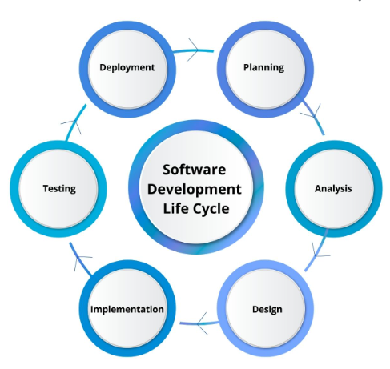
Figure 2: SDLC Methodology

7. Type of Data and Data Sources
As the data journey begins when a customer visits the branch and scans the QR code to share their feedback. Once the survey is submitted, the system starts collecting different types of data that help understand the customer experience. Some of this data is structured, such as ratings, branch name, and date, which are easy to organize and analyze in Excel. At the same time, customers also provide comments in their own words, which represent unstructured data. These comments are more valuable because they explain the reasons behind satisfaction or dissatisfaction. The system works with both real-time and historical data. Feedback is collected instantly after the customer submits the survey, allowing the organization to capture the experience at the moment it happens. Over time, this data is stored and becomes historical data, which can be used to analyze trends and measure improvement. Currently, the main data source is the QR code survey, with all responses stored in Excel sheets. However, the solution can be expanded in the future to include additional sources such as CRM or ERP systems, as well as mobile applications or social media platforms. Combining these sources would provide a more complete and accurate view of customer sentiment

8. Application of Analytics in the Proposed Solution
Analytics is not applied all at once, but rather in a sequence that starts from understanding the current situation and gradually moves toward taking action and improving customer experience. The process begins when customers scan the QR code in the branch and submit their feedback. At this stage, descriptive analytics is applied to give a clear picture of what is happening. For example, the system summarizes how many customers submitted surveys, how many were satisfied, and how many were not. This helps management quickly understand the overall performance of each branch without going through every response manually. Once this overview is available, the next step is to understand the reasons behind the results. Here, diagnostic analytics is used to analyze customer comments and identify the main causes of dissatisfaction. For instance, if a branch shows a high percentage of negative feedback, the system can reveal whether the issue is related to long waiting time, service delays, or staff behavior. This stage is important because it moves the analysis from just numbers to actual problems that need to be solved. After identifying the current issues, predictive analytics comes into play. By analyzing patterns in the QR survey data over time, the system can detect trends and estimate what may happen next. For example, if complaints about waiting time are increasing in a specific branch, the system can predict a possible decline in customer satisfaction if no action is taken. This allows the organization to act early instead of waiting for the problem to grow.
Finally, prescriptive analytics is applied to support decision-making by suggesting what actions should be taken. Based on the insights generated from the previous stages, the system can recommend practical solutions such as increasing staff during busy hours, improving service processes, or addressing technical issues. This ensures that feedback collected through the QR survey is not only analyzed but also translated into real improvements.
Overall, combining these types of analytics changes the QR survey from just a way to collect data into something actually useful for the business. Using data mining techniques like classification, clustering, and pattern detection helps in understanding customer feedback better by spotting repeated issues, grouping similar comments, and noticing trends over time. This makes it easier for management to take decisions based on real data instead of guessing, which supports continuous improvement, faster response, and a better customer experience at Fawry Plus
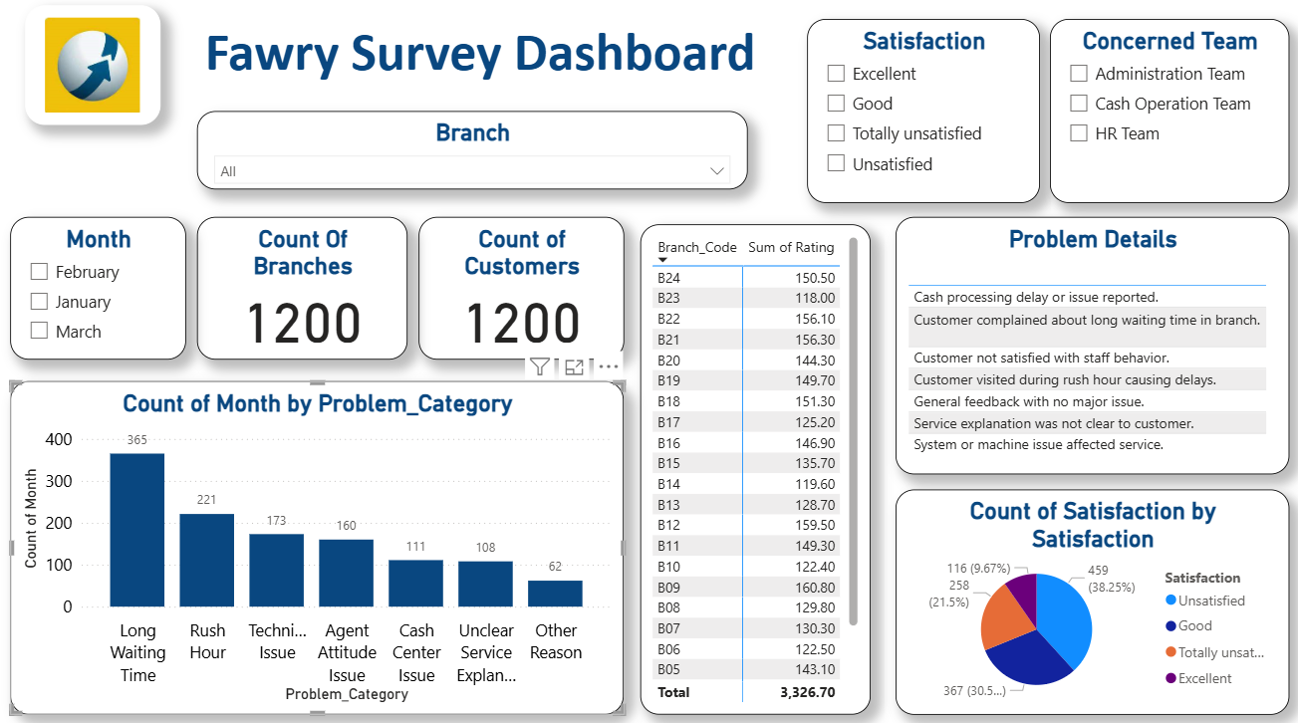

Figure 3: Power BI Dashboard for Fawry survey

9. Digital Transformation Analysis
The implementation of Artificial Intelligence in customer sentiment analysis at Fawry Plus represents a significant step toward digital transformation. It enables the organization to shift from manual, fragmented processes to an integrated, automated, and data-driven operating model. Digital transformation in this case is not limited to adopting new technology; it involves a fundamental change in how data is processed, how decisions are made, and how customer experience is managed across the organization.

9.1 Transformation of Business Processes
Before the introduction of AI, customer feedback analysis relied on a manual workflow. Employees were responsible for reviewing Excel sheets, interpreting customer comments individually, and summarizing findings. This process was time-consuming, inconsistent, and dependent on human judgment. After implementing the AI-based solution, the workflow becomes automated and standardized. Customer feedback is collected, processed, and analyzed instantly using NLP and ML algorithms, while RPA ensures smooth data flow between systems. Insights are generated in real time and presented through dashboards, eliminating delays and reducing manual effort.
This transformation improves process efficiency and ensures that feedback is consistently analyzed using the same criteria.

9.2 Automation of Manual Tasks
One of the key aspects of digital transformation is the automation of repetitive tasks. In the current system, tasks such as data collection, data entry, and report generation are performed manually, which increases the risk of errors and delays. With the integration of RPA, these tasks are fully automated. Survey responses are collected and transferred automatically, sentiment analysis is executed without human intervention, and reports are generated instantly. This allows employees to focus on higher-value activities such as decision-making and service improvement rather than routine data processing.

9.3 Impact on Decision-Making
Before AI adoption, decision-making was largely reactive. Management had to wait for reports to be manually prepared, which often resulted in delayed responses to customer issues. In addition, decisions were sometimes based on incomplete or inconsistent data. After digital transformation, decision-making becomes proactive and data-driven. Real-time dashboards provide continuous visibility into customer satisfaction levels, enabling managers to identify issues as they occur. Predictive analytics further enhances decision-making by forecasting potential problems before they escalate. This shift improves both the speed and accuracy of decisions, allowing the organization to respond more effectively to customer needs. Customer experience is significantly enhanced through the implementation of AI-driven sentiment analysis. In the previous system, customer complaints might go unnoticed or be addressed too late due to delays in analysis. In the transformed system, negative feedback is identified immediately, and alerts are generated to ensure quick action. This reduces response time, improves service quality, and increases customer satisfaction. Additionally, by analyzing patterns in customer feedback, the organization can identify common issues and implement long-term improvements, leading to a more consistent and positive customer experience across all branches.

9.4 Organizational and Cultural Impact
Digital transformation also affects organizational culture and employee roles. Previously, employees were heavily involved in manual data processing and reporting tasks. With the introduction of AI and automation, their roles shift toward analytical thinking and strategic decision-making. This requires employees to develop new skills in data interpretation and digital tools. It also promotes a data-driven culture, where decisions are based on insights rather than assumptions. However, this transformation may initially face resistance from employees who are accustomed to traditional methods. Therefore, effective change management and training programs are essential to ensure successful adoption.
9.5 Before vs. After Digital Transformation
The impact of AI-driven digital transformation can be clearly illustrated by comparing the system before and after implementation:
Aspect | Before AI Implementation | After AI Implementation
Data Processing | Manual (Excel-based) | Automated (AI-driven)
Analysis Speed | Slow | Real-time
Accuracy | Depends on human interpretation | High and consistent
Decision-Making | Reactive | Proactive & predictive
Customer Issue Response | Delayed | Immediate
Reporting | Static reports | Dynamic dashboards
Employee Role | Data processing | Insight-driven decision-making

9.6 Overall Transformation Value
Overall, the integration of AI into customer sentiment analysis transforms Fawry Plus into a more agile and responsive organization. It enhances operational efficiency, improves decision-making, and strengthens customer satisfaction. This transformation aligns with the broader goals of digital transformation in FinTech, where organizations aim to leverage technology to gain competitive advantage, improve service delivery, and create a more data-driven business environment.

10. ERP Integration & Role
The integration of Artificial Intelligence with Enterprise Resource Planning (ERP) systems plays a critical role in enhancing the effectiveness of customer sentiment analysis at Fawry Plus. ERP systems act as the central backbone that connects different business functions, ensuring seamless data flow, real-time visibility, and improved decision-making across the organization ERP is defined as an integrated enterprise system that manages core business processes such as finance, customer service, supply chain, and sales within a unified platform. It enables organizations to operate using a single source of truth, reducing data silos and improving collaboration between departments.

10.1 ERP Role in AI Implementation
In the proposed solution, ERP serves as the central system that stores, organizes, and distributes data used by AI models. While AI technologies such as NLP and ML analyze customer feedback, ERP systems provide the structured environment where this data is integrated with operational and transactional information. For example, customer sentiment data collected from QR surveys can be linked with ERP data such as branch performance, transaction volumes, and customer service records. This integration enables a more comprehensive understanding of customer experience by combining qualitative feedback with quantitative business data. Additionally, ERP systems ensure that insights generated by AI are accessible across departments, allowing different teams to take coordinated actions based on the same data.

10.2 ERP Modules Involved
At Fawry Plus, ERP implementation focuses on several key modules, particularly through Microsoft Dynamics 365. These modules support both operational processes and AI-driven insights:
- Finance & Accounting Module:
Handles financial transactions, settlements, and reporting. It allows integration of customer sentiment insights with financial performance, enabling analysis of how customer satisfaction impacts revenue.
- Customer Service Management Module:
Captures customer interactions from multiple channels (branches, call centers, mobile apps, and social media). It integrates directly with sentiment analysis results, allowing better issue tracking and faster resolution.
- Supply Chain Management Module:
Manages logistics, inventory, and service-related resources such as POS devices. AI insights can highlight operational inefficiencies affecting customer experience.
- Sales & Contracts Management Module:
Supports merchant onboarding and service agreements, allowing sentiment data to be linked with partner performance and service delivery quality.
These modules collectively provide a unified system where AI insights can be applied across multiple business functions.

10.3 Integration Between AI and ERP Systems
The integration between AI tools and ERP systems is achieved through a structured data flow that connects customer feedback with enterprise operations.
- Customer feedback is collected through QR surveys
- RPA transfers the data into the analytics environment
- NLP and ML analyze sentiment and classify feedback
- The results are integrated into ERP dashboards (Dynamics 365, Power BI)
- Insights are linked with operational data such as branch performance and service metrics
This integration ensures that AI outputs are not isolated but embedded within the organization’s core systems, enabling real-time monitoring and action. Power BI plays a key role in visualizing this integrated data by providing interactive dashboards that display KPIs such as customer satisfaction rates, complaint frequency, and branch performance.
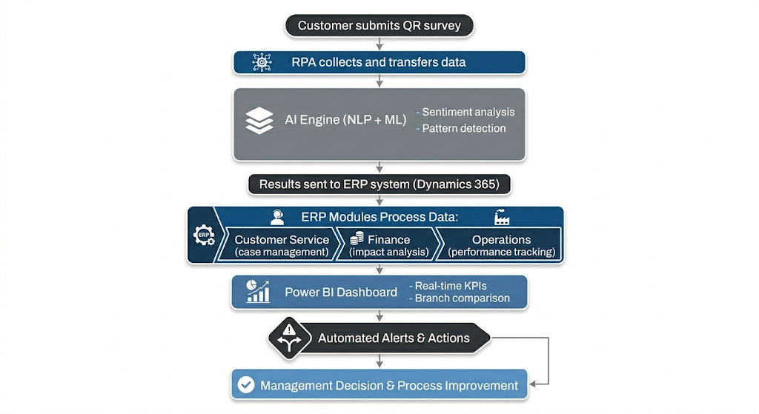
Figure 4: AI–ERP Integrated Workflow

10.4 Benefits of ERP and AI Integration
Integrating AI with ERP systems provides several key benefits:
- Real-Time Visibility:
Decision-makers have immediate access to updated customer sentiment data combined with operational metrics.
- Improved Decision-Making:
AI insights are enriched with ERP data, enabling more accurate and informed decisions.
- Enhanced Collaboration:
Different departments work using the same data, reducing inconsistencies and improving coordination.
- Operational Efficiency:
Automated workflows reduce manual effort and improve response time to customer issues.
- Compliance and Audit Readiness:
ERP systems maintain detailed logs and audit trails, supporting regulatory compliance and ensuring transparency.
ERP systems are not just supporting tools but a key enabler of the proposed AI solution. They ensure that insights generated from customer sentiment analysis are fully integrated into business operations, enabling faster response, better coordination, and continuous improvement. By combining AI capabilities with ERP systems, Fawry Plus can achieve a fully integrated, data-driven ecosystem where customer feedback directly influences operational decisions and business strategy.
11. Business Impact & Value Creation
The implementation of an AI-driven customer sentiment analysis system integrated with ERP at Fawry Plus generates significant business value across financial, operational, and strategic dimensions. By transforming customer feedback into actionable insights, the organization enhances efficiency, improves service quality, and strengthens its competitive position in the FinTech market.

11.1 Financial Impact
From a financial perspective, the proposed solution contributes to both cost reduction and revenue enhancement. First, automation through AI and RPA reduces the need for manual data processing and analysis, leading to lower operational costs. Employees spend less time reviewing Excel sheets and preparing reports, which decreases labor costs and improves productivity. Second, improved customer satisfaction directly impacts revenue. When customer issues are identified and resolved quickly, the likelihood of customer retention increases. Satisfied customers are more likely to continue using services, recommend the company to others, and engage in additional transactions. Moreover, the system helps identify service inefficiencies that may cause financial losses, such as delays or technical issues. Addressing these problems reduces transaction failures and improves overall service reliability, which positively affects revenue generation.

11.2 Operational Efficiency
Operational efficiency is significantly enhanced through the automation and integration of processes. Previously, customer feedback analysis was slow and inconsistent due to manual handling. With the AI-driven system, feedback is processed instantly, and insights are generated in real time. This reduces response time and ensures that issues are addressed promptly. In addition, RPA automates repetitive tasks such as data collection, data transfer, and report generation, reducing human error and increasing consistency. ERP integration further enhances efficiency by centralizing data and enabling seamless communication between departments. As a result, workflows become more streamlined, and employees can focus on value-added activities rather than routine tasks.

11.3 Strategic Advantages
The proposed solution provides several strategic advantages that strengthen Fawry Plus’s position in the FinTech industry.
- Data-Driven Decision-Making:
Management can rely on real-time insights and predictive analytics rather than intuition, leading to more accurate and effective decisions.
- Competitive Advantage:
The ability to analyze customer sentiment in real time allows Fawry Plus to respond faster than competitors, improving customer experience and brand reputation.
- Scalability:
The AI-based system can handle increasing volumes of customer feedback without requiring proportional increases in resources, making it suitable for business growth.
- Innovation Enablement:
The integration of AI and ERP creates a foundation for future innovations, such as personalized services, predictive customer support, and advanced analytics.

11.4 Key Performance Indicators (KPIs)
To effectively measure the success of the proposed AI-based solution, a set of well-defined Key Performance Indicators (KPIs) is essential. These KPIs provide both operational and strategic insights, allowing management to continuously monitor performance, identify gaps, and take corrective actions in no time.
Customer Satisfaction Score (CSAT) is one of the primary indicators used to measure overall customer satisfaction. It is typically calculated based on customer ratings collected through the QR survey. A higher CSAT score reflects a better customer experience and indicates that services are meeting or exceeding expectations. Tracking CSAT over time also helps in evaluating the impact of implemented improvements.
Sentiment Distribution provides a breakdown of customer feedback into positive, negative, and neutral categories. This KPI offers a quick overview of overall customer perception and helps identify trends or shifts in sentiment over time. It also supports deeper analysis when combined with other KPIs, such as branch performance or problem categories.
Branch Performance Index compares service quality across different branches by combining multiple indicators such as satisfaction levels, complaint frequency, and resolution rates. This allows management to identify high-performing branches as well as those that require improvement, enabling more targeted and effective decision-making.
All these KPIs can be monitored through ERP-integrated dashboards, such as Power BI, which provide real-time visibility into performance. This integration ensures that data is centralized, updated continuously, and accessible to decision-makers, allowing for faster and more informed actions.
11.5 Overall Value Creation
The proposed solution supports long-term sustainability by enabling a continuous improvement cycle driven by data. As more customer feedback is collected over time, the Machine Learning models become more accurate and better at detecting patterns, trends, and sentiment. This continuous learning process enhances the reliability of insights and ensures that the system evolves alongside customer expectations. In addition, the integration with ERP systems plays a crucial role in maintaining sustainability. By embedding sentiment analysis into existing business processes, the solution becomes part of the organization’s daily operations rather than a standalone tool. This allows for seamless data flow between departments, improved coordination, and better alignment with business objectives. The system is also designed to be scalable, meaning it can handle increasing volumes of data as the organization grows. Whether the number of branches expands or customer interactions increase, the solution can adapt without compromising performance. This scalability ensures that the system remains effective in both current and future operational environments Additionally, continuous monitoring and periodic model updates allow the system to adapt to changing customer behavior, new service offerings, and evolving market conditions. This flexibility ensures that the solution remains relevant and capable of delivering value over the long term.

12. Risks, Ethical Issues & Limitations
While the implementation of AI-driven customer sentiment analysis provides significant benefits, it also introduces several risks, ethical concerns, and limitations that must be carefully managed. Addressing these issues is essential to ensure responsible, secure, and sustainable use of AI within Fawry Plus.

12.1 Data Privacy and Security (GDPR Considerations)
One of the primary concerns in AI-based systems is the handling of customer data. Customer feedback collected through QR surveys may contain sensitive or personal information, which must be protected to ensure compliance with data protection regulations such as the General Data Protection Regulation (GDPR).AI systems must ensure that data is processed in a lawful, transparent, and secure manner. This includes:
- Collecting only necessary data (data minimization)
- Ensuring customer consent when collecting feedback
- Storing data securely to prevent unauthorized access
- Anonymizing or masking personal information when possible
Failure to comply with these principles may lead to legal penalties, reputational damage, and loss of customer trust.

12.2 Bias in AI Models
AI models, particularly those used in sentiment analysis, may produce biased results if the training data is not balanced or representative. For example, certain expressions or language styles may be incorrectly classified as negative or positive due to bias in the dataset.
This can lead to unfair or inaccurate conclusions, affecting decision-making and potentially resulting in inappropriate actions by management.
To reduce bias, the organization should:
- Use diverse and representative training data
- Continuously monitor model performance
- Apply fairness evaluation techniques
- Regularly retrain models to improve accuracy
Ensuring fairness and objectivity in AI models is essential for maintaining trust and reliability.

12.3 Regulatory and Compliance Risks
In addition to GDPR, FinTech companies like Fawry Plus operate under strict regulatory frameworks, including Central Bank regulations and Anti-Money Laundering (AML) requirements. The integration of AI and ERP systems must comply with these regulations, ensuring that all processes are transparent, auditable, and aligned with legal requirements. Any failure in compliance may result in regulatory penalties and operational restrictions ERP systems help mitigate these risks by maintaining audit trails and tracking all system activities, which supports regulatory reporting and accountability.

12.4 Technology Adoption Risks
The adoption of AI and ERP technologies may face several implementation challenges:
- Resistance from employees who are used to manual processes
- Complexity of integrating AI with existing systems
- Need for training and skill development
- Dependence on technology infrastructure
If not properly managed, these challenges may delay implementation and reduce the effectiveness of the solution.

12.5 Limitations of AI and ERP Systems
Despite their advantages, AI and ERP systems have certain limitations:
- AI models may not fully understand complex human language, sarcasm, or mixed sentiment
- Sentiment classification accuracy depends on data quality
- ERP systems require significant investment and customization
- Integration between systems may require time and technical effort
These limitations highlight the importance of continuous monitoring, improvement, and human oversight.

12.6 ISO 27001 and Information Security
To strengthen data security and ensure best practices, the proposed solution aligns with ISO 27001, which is an international standard for information security management.
A key relevant control from ISO 27001 is:
- Access Control (ISO 27001 – Annex A.9):
Ensures that only authorized users can access sensitive data and systems. This is particularly important when handling customer feedback and integrating AI with ERP systems.
Additional relevant controls include:
- Data Protection and Encryption (Annex A.10): Protecting data during storage and transmission
- Logging and Monitoring (Annex A.12): Tracking system activities for security and audit purposes
By applying these controls, Fawry Plus can ensure that its AI-driven system operates securely and complies with international standards.

12.7 Ethical Considerations
Beyond technical risks, ethical considerations must also be addressed. The use of AI in analyzing customer feedback should be transparent, meaning customers should be aware that their data may be analyzed using automated systems.
In addition, decisions based on AI insights should always include human oversight to ensure fairness and avoid over-reliance on automated systems.
Maintaining ethical AI practices enhances customer trust and supports long-term business sustainability.

12.8 Summary of Risks and Mitigation
Risk | Impact | Mitigation
Data privacy issues | Legal penalties, trust loss | GDPR compliance, data anonymization
AI bias | Inaccurate decisions | Balanced data, model monitoring
Regulatory risks | Compliance issues | ERP audit trails, governance
Adoption resistance | Implementation delays | Training & change management
System limitations | Reduced accuracy | Continuous improvement

13. Recommendations & Future Scope
Based on the analysis of the current system and the proposed AI-driven solution, several strategic recommendations can be made to enhance the effectiveness of customer sentiment analysis and support continuous digital transformation at Fawry Plus.

13.1 Strategic Recommendations

1. Expand Data Integration Across Channels
Currently, customer feedback is mainly collected through QR-based surveys in branches. To improve analysis accuracy and gain a more comprehensive view of customer experience, it is recommended to integrate additional data sources such as:
- Mobile applications
- Call center interactions
- Social media platforms
- CRM and ERP systems
This will allow the organization to capture customer sentiment across all touchpoints and improve the quality of insights.

2. Enhance Machine Learning Models
The performance of sentiment analysis models can be further improved by:
- Increasing the volume of labeled training data
- Applying advanced models such as deep learning (LSTM or transformer-based models)
- Continuously retraining models using new data
This will improve classification accuracy and enable more precise detection of customer sentiment and behavior patterns.

3. Strengthen Real-Time Decision Capabilities
To maximize the value of the system, Fawry Plus should enhance real-time analytics capabilities by:
- Implementing live dashboards with automatic updates
- Setting dynamic thresholds for alerts
- Enabling instant escalation of critical issues
This will ensure faster response to customer complaints and improve service quality.

4. Improve Employee Training and Change Management
Successful implementation of AI and ERP systems requires employees to adapt to new tools and workflows. It is recommended to:
- Provide continuous training programs
- Promote data-driven decision-making culture
- Encourage user adoption through awareness initiatives
This will reduce resistance and ensure effective utilization of the system.

5. Strengthen Data Governance and Security
To ensure compliance and maintain customer trust, the organization should:
- Implement strict data governance policies
- Regularly audit data access and usage
- Apply ISO 27001 controls and security best practices
This will protect sensitive data and ensure regulatory compliance.

13.2 Future Scope
The proposed solution provides a strong foundation for future advancements in AI and digital transformation.

1. Advanced AI Capabilities
Future enhancements may include:
- Predictive customer behavior analysis
- Personalized service recommendations
- Automated Chabot integration for customer support
These capabilities can further improve customer engagement and satisfaction.

2. Expansion of ERP–AI Integration
The integration between AI and ERP systems can be extended to:
- Supply chain optimization
- Financial forecasting
- Fraud detection
This will enable the organization to apply AI insights across all business functions, not only customer service.

3. Use of Advanced Analytics and Big Data
As data volume grows, the organization can leverage big data technologies to:
- Analyze large-scale datasets
- Detect complex patterns
- Support strategic decision-making

4. Continuous Digital Transformation
Digital transformation is an ongoing process. Fawry Plus should continuously evaluate and upgrade its systems to remain competitive in the FinTech industry and adapt to changing customer expectations.

14. Conclusion
This study examined the application of Artificial Intelligence in customer sentiment analysis to improve customer experience at Fawry Plus. The analysis highlighted the limitations of the current manual system, which relies on Excel-based feedback review and lacks real-time insights, consistency, and scalability.
To address these challenges, the study proposed an integrated solution combining Natural Language Processing (NLP), Machine Learning (ML), and Robotic Process Automation (RPA), supported by ERP systems such as Microsoft Dynamics 365. This solution enables automated data processing, accurate sentiment classification, and real-time analytics, transforming customer feedback into actionable insights. The findings demonstrate that the implementation of AI and ERP integration leads to significant improvements in operational efficiency, decision-making, and customer satisfaction. It also supports digital transformation by automating workflows, enhancing collaboration, and enabling a data-driven organizational culture. However, the study also identified key risks and challenges, including data privacy concerns, potential bias in AI models, and implementation complexity. Addressing these issues through proper governance, compliance with standards such as GDPR and ISO 27001, and continuous system improvement is essential for sustainable success.
In conclusion, the integration of AI in customer sentiment analysis provides Fawry Plus with a strong competitive advantage by enabling faster, smarter, and more responsive service delivery. As the organization continues to evolve, leveraging advanced AI technologies and expanding ERP integration will further enhance business performance and support long-term growth.

15. References
Davenport, T. H., & Ronanki, R. (2018). Artificial intelligence for the real world. Harvard Business Review, 96(1), 108–116.
Russell, S., & Norvig, P. (2021). Artificial intelligence: A modern approach (4th ed.). Pearson.
Jurafsky, D., & Martin, J. H. (2023). Speech and language processing (3rd ed.). Pearson.
Chen, H., Chiang, R. H. L., & Storey, V. C. (2012). Business intelligence and analytics: From big data to big impact. MIS Quarterly, 36(4), 1165–1188.
Wamba, S. F., Akter, S., Edwards, A., Chopin, G., & Gnanzou, D. (2015). How big data can make a big impact: Findings from a systematic review. International Journal of Production Economics, 165, 234–246.
Kelleher, J. D., Namee, B. M., & D’Arcy, A. (2020). Fundamentals of machine learning for predictive data analytics (2nd ed.). MIT Press.
Microsoft. (2023). Microsoft Dynamics 365 documentation. Retrieved from https://learn.microsoft.com
IBM. (2023). What is natural language processing (NLP)? Retrieved from https://www.ibm.com/topics/natural-language-processing
SAP. (2023). What is ERP? Retrieved from https://www.sap.com/products/erp/what-is-erp.html
European Union. (2018). General Data Protection Regulation (GDPR). Retrieved from https://gdpr.eu
International Organization for Standardization. (2013). ISO/IEC 27001: Information security management systems requirements. ISO.
McKinsey & Company. (2022). The state of AI in 2022—and a half decade in review. Retrieved from https://www.mckinsey.com

